Tufts University
School of Engineering

Senior Design Project
EE97
Spring 2002

FPGA Implementation of a

Mini Graphics Processor

Paul D’Orlando | Weyant Stone | Yuri Grinshteyn

Abstract
This report describes the original motivation behind the digital image processor, the design process undergone during its creation, and the final product’s implementation, functionality, and significance.

The major issues faced by the designers, namely data storage, memory control, data processing, and output implementation, are addressed. The project’s current implementation is outlined, and possible directions for future research are discussed.
Acknowledgements and Special Thanks

Tufts University EECS Department
Professor Chong Hwa Chang
Professor Karen Panetta
Professor Stephen Morrison
Paul Olson
David Scher

John Bottari
Warren Gagosian

Professor Soha Hassoun

Table of Contents

Overview and Introduction |  | 6
Hardware Discussion |  | 8
FPGA Analysis |  | 13
What is VGA? |  | 16
Generating Modules (Program Discussion) |  | 18
Software (MaxPlus II) |  | 21
Laboratory Report |  | 23
 | Objective | 23
 | Materials | 23
 | Procedure | 23
 | Results | 28
 | Conclusions | 31
 | References | 33
Appendix |  | 34

Table of Figures

Figure 1 Internal Structure of an FPGA 13

Figure 2 The internal layout of the FLEX 10K 14

Figure 3 Altera UP-1 Student Demo Board 15

Figure 4 Jumper Setup for MAX Chip Use 24

Figure 5 Jumper Setup for FLEX Chip Use 25

Figure 6 D-Sub Connections 25

Figure 7 FLEX Chip Signal Names and Device 26

Connections

Figure 8 EPROM Data VGA View 29

Figure 9 Blank RAM VGA View 30

Figure 10 RAM Data VGA View 30

Overview and Introduction
The purpose of the following report is to provide a detailed explanation for the motivation, intent, design, and implementation of the outboard graphics processor designed and prototyped by Paul D’Orlando, Weyant Stone, and Yuri Grinshteyn. This report will illustrate the original intent of and the motivation for the device, as well as outline the design process, testing strategies, and the final prototype. The conclusions reached as a result of the design will also be presented, as well as material for possible future improvements, enhancements, and further research.

The project was originally intended to become an extension of the final project completed by the designers for the VLSI design class. The final project for this class consisted of using the Verilog hardware descriptor language to design a graphics processor module, which was capable of interfacing with a separately created and implemented memory module to retrieve a black and white image encoded in hexadecimal, perform one or both of two possible processing operations, and write the processed image back to the memory. The design was capable of performing a pixel-wise intensity shift, where the value of each black and white pixel was adjusted based on an assigned factor, and a filtering adjustment, where the value of each pixel was adjusted to become a weighted average of the pre-adjustment values of its immediately neighboring pixels. The design functioned by reading 128 bytes from memory, determining the data to contain pixel values, intensity shift factors, or filtering average weights, performing the operation on the data as specified by the opcode input, and writing the processed data back to memory as a 128 byte packet. To accomplish this, the design used a 130-byte wide bus, making the design a purely theoretical exercise, as the integrated circuit synthesized by the design tool based on the code specifications had a floorplan area of nearly one square foot and a power consumption metric of more than seventy milliwatts. However, the design was both functionally correct and incredibly fast – the processing of a 512x512 pixel image required around 25000 clock cycles, while competitive designs took as many as 1 million. The digital engineering tradeoffs in this case were very heavily in the favor of performance, sacrificing price, power consumption, and area.

The original intent for the design described here was to become an extension of this graphics processor. It was intended to implement the design on an FPGA, albeit with the necessary modifications to allow the circuit to fit on a conventional FPGA. The major modification necessary would have been to change the design to operate using an 8-bit bus and reading one byte at a time from memory, drastically reducing performance, but allowing the physical implementation to become feasible. Furthermore, an infrared port was to be used to communicate between the design on an FPGA and a Palm™ Pilot handheld device to allow the design to both receive the image from the handheld and write the processed information back to the handheld’s memory. To accomplish this, some knowledge of the Palm™ operating system and programming for it would have been necessary, as well as knowledge of the infrared communication port standards and their interfacing with other devices.

After some initial investigation, the project specifications were changed quite significantly. The original project proved to be too time-consuming and difficult for the scope of this design. The goal, then, became to build an interface between two memory modules, in this case, read-only memory implemented on an EPROM and random-access memory implemented on SRAM chips, that would also allow for processing of the data sent between the memories and outputting the data to a VGA display using a VGA driver also implemented on the FPGA. The VGA driver forced some compromises: since each pixel on the display at any one time can be only be defined by three bit values, representing red, green, and blue, only eight colors are possible, including black and white (it should be noted that a full range of colors is possible to achieve using a more complicated VGA driver with a dithering algorithm. For a full discussion of this, refer to the appropriate section entitled “What is VGA?”). Therefore, a simple color pattern was chosen to use in the prototype.

During the design, a number of choices and compromises had to be made. The most important choice was the one of technology to be used. FPGA (field-programmable gate array) was chosen due to its low price, ease of availability, programming, and use, and its status as the industry standard for rapid and inexpensive prototyping. Clearly, the use of an ASIC (application-specific integrated circuit) would have been prohibitive here both due to its difficulty of prototyping, requiring fabrication processes available only in a factory setting, and high price. Next, the FPGA itself had to be chosen, as many models are commercially available. The design uses the Altera® UP-1 board, which contains two gate arrays – the EPM7128S device in an 84-pin package and the EPF10K20 device in a 240-pin package. The 10K20 chip was used, since it is the by far larger chip and is packaged with many more in/out pins available. The board also contains a VGA port interfaced to the EPF10K20 chip, which was used for VGA output. The board was chosen because of its immediate availability and ease of interfacing to a VGA display. Next, the method of programming the FPGA was needed. The UP-1 board included the ByteBlasterMV™ parallel port download cable, which was used to transfer the synthesized circuit information from a PC running Altera’s Max+PLUS II Version 10.1 software, used to write the Verilog and VHDL code for the design specification, to the 10K20 chip on the board. The memory chips also needed to be chosen. To implement the ROM, AMD AM27C512 64Kx8 bit EPROM chips were used. To implement the RAM, Utron UT621024 128Kx8 bit CMOS SRAM chips were used. Next, a method of initializing the read-only memory was needed. The 27C512 EPROM is compatible with the MegaMax™ programmer, and the MegaMax™ was used throughout. The final problem consisted of interfacing the controller implemented on the 10K20 chip to both ROM and RAM, as issues of voltage levels, timing constraints, and compatibility had to be addressed. A breadboard was used to house the chips and interface to the 10K20 chip on the UP-1 board, which, in turn, had to be fitted with headers for the chip in order to allow easier wiring of the data and address (for a more in-depth discussion, please refer to the section entitled “Hardware Discussion”).

Hardware Discussion
Several questions had to be answered in selecting the hardware to be used. The image needed to be stored both before and after undergoing processing. The memory needed to be read to access the image, which then required processing. Finally, the processed image needed to be stored back to memory.
It was determined that a solid, static, non-volatile piece of memory was needed to store the original image. The image to be manipulated was going to contain one byte of data per pixel. Therefore, the size of the memory device chosen was based upon what the expected size of the image was going to be. Thus, in order to have a decent size image with a byte per pixel, that involves a memory device that can contain 512KB of data. Through suggestion of the professor, the use of an EEPROM was determined a best fit for the image itself.

EEPROMs are electronically erasable programmable read-only memory. It is a variety of PLA, or programmable logic array. EEPROMs are a series of transistors within a chip that are programmed by applying a higher than normal voltage level to them, causing a large amount of current to flow through the transistor’s channel. The high current flow through the channel generated by programming the chip causes a Fowler-Nordheim tunneling effect to occur, where electrons become trapped within the transistor. After programming, these trapped electrons prevent other electrons from entering the channel. Thus, when the nominal voltage of 5V that normally turns the transistor on is applied, these trapped electrons keep the transistor off and the inputs are no longer connected to the gate array inside. Therefore, once an EEPROM transistor has been programmed, it retains the programming logic permanently. The method used to erase this programming is to apply a voltage of opposite polarity, causing the trapped electrons to tunnel back out into the channel.

For the project however, due to materials already at hand in the department, a slightly better option was determined. Instead of an EEPROM, an EPROM would be used. The EPROM simply stands for erasable programmable read-only memory. The functionality of this device is almost exactly like the EEPROM with one major difference. An EPROM transistor is erased by exposing it to the wavelengths found in ultraviolet light. In order to do this, the packaging contains a small window that shows the chip inside. An EPROM eraser is then used to expose that chip to ultraviolet light to erase the data stored on it.

Therefore, due to their extraordinary ability to statically hold and sustain data, even after power down, the ability to erase the chip electronically, and due to the fairly good availability, the Am27C512 EPROM was chosen. (Please refer to the attached data sheet in the Appendix) The designation of 512 in the naming scheme of the EPROM does not actually stand for the 512KB of storage. Rather, EPROMs, as it was discovered, are listed and described in terms of their size in bits. Thus, this is a 512Kb EPROM, organized into 64K words by 8 bits per word. Thus, from the beginning, the original plan to have a large grayscale image began to fade.

There were other considerations that needed to be taken into account in determining which variety of EPROM would be needed. Chips come in all shapes, sizes, speeds, and strengths. For this project, a large-scale chip was needed with easily accessible pins. After a bit of research, the 28-pin DIP package type was determined to be the appropriate choice. Another consideration to be taken into account was the strength of the chip. Chips generally come in one of four varieties: commercial, industrial, military, or extended. Choosing which variety was best was not difficult. Commercial chips support the smallest temperature range (0ºC to +70ºC), well within an acceptable range for the project, and most importantly, the cheapest variety. The next consideration to take into effect was the speed of the chip. It seemed as though there was an abundance of 150ns access time chips. After reviewing the data sheet on the chip showing the switching waveform, and determining that the clock on the demo board was around 25.175MHz, it was confirmed that 150ns chips were acceptable. This would again come into play when determining the speed of chips later.

The final advantage to using the specified EPROM chip was the availability of the MegaMax© downloading unit and software. The Am27C512 is supported by the MegaMax© downloader. In short, this software is loaded to the hard drive and the hardware is simply a unit that attaches to the computer via a parallel cable. The software is then used to generate a simple hex file that will become the data on the EPROM at the specified addresses. The chip is then mounted into the unit and the data is downloaded to the chip. If an error is made, the data can either be written over or the ultraviolet tray can be used to blank all the data that was previously loaded.

The second major issue to be dealt with was what would be the major piece of hardware that would be used to hold the modified image. This device needed to be easily accessed, easily written to, and easily read from. The logical choice in such a situation is an SRAM, or static random access memory. SRAMs are memory devices that do not lose their data when the power is turned off like DRAMs (dynamic random-access memory). SRAMs are usually used for fast speed cache memory. An SRAM bit is made of a pretzel-like flip-flop circuit of transistors that lets current flow through one side or the other based on which one of two transistors is activated. In general, SRAMs are larger and more expensive than DRAMs.

The RAM chip selected was the UT621024-70. This chip is a 1024 bit chip. As was eventually discovered, memory chips are classified in terms of their size in bits. Thus, a 1024 bit memory chip is truly a 128K x 8 chip. Thus, this chip would essentially hold 128K of data, twice that of the EPROM being used. The next question that begs to be asked is how to quickly, simply, and easily make sure that data is not written into the unwanted area of RAM? The solution is trivial. The highest order address bit simply needed to be grounded, so that the higher order addresses were never seen.

The next hurdle to tackle was how to access the RAM chip in terms of reading, writing, and holding data. For this, the waveform and truth table provided by the manufacturer were consulted (please see the UT621024 data sheet attached in the appendix). There were two different types of read and write cycles on the chip, and thus one needed to be chosen. The first read and write cycles were dependent simply upon the “write enable” (WE#) signal going into the chip. The second variety of read and write cycles were dependent upon the CE1#, CE2, and OE# signals going into the chip. In order to keep the project as simple as possible, the first flavor of read and write cycles was chosen. Thus, now proper signals needed to be determined in order to read and write to the RAM properly. The first operation that will occur with the RAM is writing. Thus, by studying the waveform, it can be determined that in order to write to RAM, the CE1# needed to be tied to ground and the CE2 signal needed to be tied to V_{cc}. The WE# signal presented another challenge. The RAM chip writes when the signal is low. The RAM is an asynchronous device, however, meaning that it is not dependent upon clock cycles. The problem was solved by tying the WE# pin to a dipswitch on the board. For financial reasons, a 70ns access time chip was purchased that proved to be compatible with the overall timing of the project. The “Data to Write Time Overlap” was a minimum of 30ns. This was not an issue due to the fact that the WE# state does not change during a write cycle. The same goes for the Read Cycle time. It needed to be a minimum of 70ns. Thus, with the address changing at 25MHz, that left plenty of time to read from RAM.

Finally, a device to hold the programmable logic to perform the memory and processing operations was needed. In order to remove data from the EPROM, manipulate that data, and write it back to SRAM from which the image would be viewed, a strong, programmable, and versatile device was necessary. The group decided upon the use of an FPGA for this purpose. FPGAs are field-programmable gate arrays. These chips contain millions of transistors that make up large numbers of logic circuit elements, which can be connected together using programmable switches. FPGAs are a variety of programmable logic device (PLD), however unlike other PLDs, FPGAs do not contain AND and OR gates. Instead, it contains logic blocks that are used to implement functions. These logic blocks are accessed via I/O blocks that run along the outside edge of the chip and are connected via the interconnection switches as seen in the figure below.

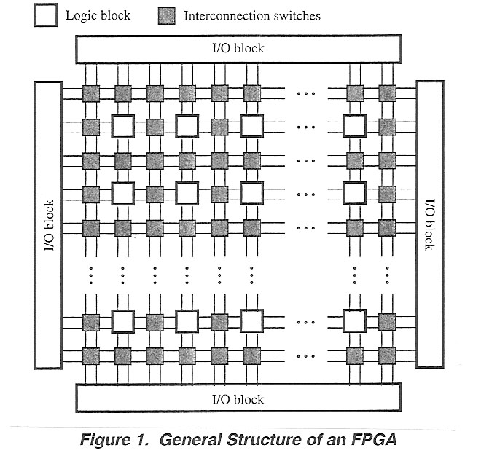

FPGAs are able to quickly implement circuits of a few hundred thousand gates or more with no problem. Thus, the FPGA was chosen due to its versatility and immediate availability.

The specific FPGA that was used was the Altera® FLEX 10K20RC240-4. This chip in particular comes in a 240-pin package and has 1,152 logic elements (LE) and 6 embedded array blocks (EAB) as seen below. The LEs contain a programmable flip-flop and dedicated signal paths for carry and cascade functions. The EABs can be configured to provide 2Kb of memory to be used for ROM, RAM, or FIFO implementation. The EABs, however, can also be used to implement logic functions, such as multipliers, microcontrollers, state machines, and digital signal processors. This feature of the chip was the key to the design of the project.

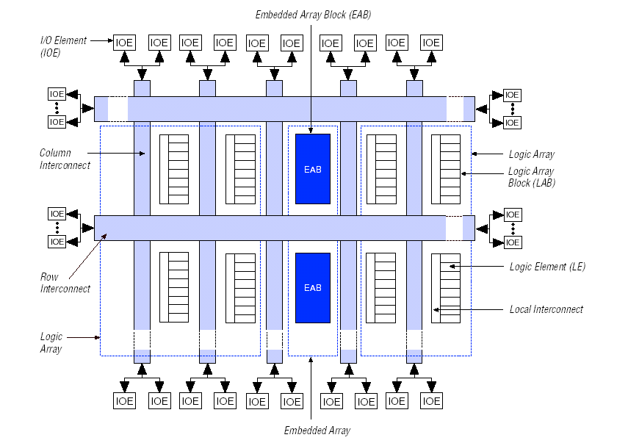
Figure 2. The internal layout of the FLEX 10K (courtesy of Altera)

The FLEX10K chip was also used due to the readily available Altera® UP-1 student demo board. The majority of time spent on the project dealt with becoming familiar with this board and the different features that were available. As can be seen below, the UP-1 board has two separate FPGA on it. The first is the EPM7128S (MAX 7000S) and the second is the EPF10K20 (FLEX 10K20). The MAX chip is significantly smaller with a capacity of 2,500 gates and comes in an 84-pin package while the FLEX chip is significantly larger as stated before. The MAX chip does come socket-mounted however, while the FLEX chip was not. In order to access the pins of the FLEX chip, the through-holes that run along the right side of the board needed to connect to some sort of I/O. Originally, wires were simply inserted into the holes without any permanent or semi-permanent means to ensure proper contact. This proved to be unreliable and tedious, as well as confusing if something did not work properly. Therefore, female headers were soldered to the connections that were needed to create an almost breadboard like attachment for wires running from the EPROM and the SRAM.

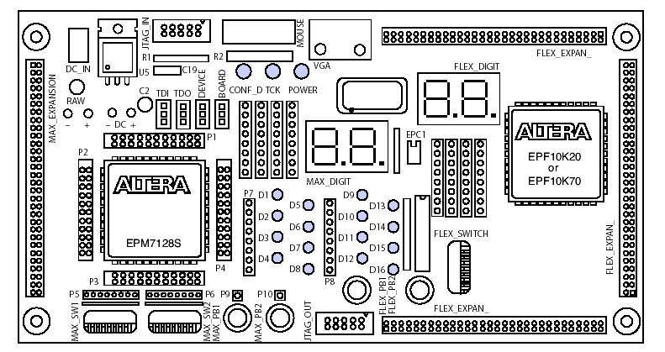
Figure 3. Altera® UP-1 student demo board

A few other items to note on the board are the on-board voltage regulator, the oscillator, the JTAG_IN header, the jumpers, the dip switches, and the VGA interface that are available for both the MAX and FLEX chips. The on-board voltage regulator regulates the DC power on the board to positive 5V. The same 5V was used to power each of the two chips on-board as well as the EPROM and RAM. This was possible because the 5V source is routed to various through-holes on the board. The UP-1 also contains a 25.175 crystal oscillator that gives the global clock input to the MAX chip and the FLEX chip (at pin 91). The clock is specified at such a speed so as to match that of the refresh rate of a VGA driver (please refer to the section entitled “What is VGA?”). The clock was also conveniently used to act as the WE# signal on the RAM chip. The JTAG_IN header is a 10-pin male connector that connects with the 10-pin female plug of the ByteBlasterMV™ download cable. The ByteBlasterMV™ download cable is simply a hardware interface to a standard parallel port. The cable channels programming and/or configuration data between the Max+PLUS II software (please refer section of the report entitled “Software”) and the UP-1. The board provides power and ground to the ByteBlasterMV™ download cable, which communicates by sending data into the devices via the TDI pin, and data out of the devices via the TD0 pin. The jumpers on the board are located directly about the socket-mounts of the MAX chip. There are 4 3-pin jumpers: TDI, TDO, DEVICE, and BOARD that set the JTAG configuration. The FLEX chip was the only one used on the board, therefore the group was only concerned with programming that one device. (The exact jumper setting used will be discussed in the procedure portion of the report). Another feature of the board that was utilized for the project were the dipswitches. These switches are located diagonally beneath the FLEX chip on the UP-1. There are eight switches that provide logic-level signals to eight general-purpose I/O pins on the FLEX device. They are operated on negative logic reasoning. Thus, a logic 1 is set when the switch is open and a logic 0 is set when the switch is close. The final feature of the board was the VGA interface. This device is controlled by the FLEX chip alone and allows for the control of an external VGA monitor. The interface itself is composed of a simple diode-resistor network and a 15-pin D-sub connector, where the monitor plugs into the UP-1. The diode-resistor network and D-sub are designed to generate voltages that are appropriate to the VGA standard. The use of the VGA interface and the software used to drive it are covered in more depth in the software portion of the report. Please refer to that section for more information on their operation.

What is VGA?
This project was largely defined by its interface with a VGA or Video Graphics Adapter. An image processor is useless if the image is never viewable. The Altera UP1 prototyping board comes equipped with a VGA mount, its pins being hardwired to pins on the FLEX10K20 FPGA. The board was selected largely because of this feature. A great deal of time was spent learning and understanding the VGA functionality in order to create an efficient design to interact with it.

The construction of a VGA monitor is not very complicated. The color Cathode Ray Tube, or CRT, interacts with an electron beam. A deflection yoke uses electrostatic fields to deflect the beam to the correct position on the screen. The beam is scanned over the surface of the screen horizontally, line by line and top to bottom. Light is generated by the beam and strikes the phosphors contained in the CRT. Three different types of phosphors interact with the light to create three different colors. The RGB signals sent to the VGA determine the strength of the light beam, which determines the resulting visible color.

A VGA video screen is controlled by 5 signals. The color signals are defined by the analog RGB signals, respectively, the Red, Green and Blue signals. Two TTL-compatible signals, Vertical Sync and Horizontal Sync, direct the color information from these three signals. A VGA screen refreshes the picture elements, or pixels, 60 times per second in most monitor models. The electron gun begins displaying the data one pixel at a time starting in the top left hand corner of the screen and moving horizontally to the right of the screen. Once it reaches the 640th pixel, the horizontal sync signal, which is active-low, pulses low. The electron gun then returns its aim to the left side of the screen and begins displaying the next row. The Horizontal Sync signal will pulse at the end of every row. After 480 Horizontal Sync signals, the Vertical Sync signal pulses low, and the electron gun returns to the top left corner of the screen. A counter in the VGA monitor keeps track of how many pixels have been generated in that row. Once the counter reaches 640, the Horizontal Sync signal activates and the counter resets. This increments another counter that keeps track of the vertical position. Once that counter reaches 480, the vertical sync signal activates, resetting the counter and the screen refreshes.

This entire sequence happens 60 times per second (refresh rate). Standard VGA displays 640 by 480 pixels in one refresh frame. Every rising edge of a clock pulse, a pixel is displayed on the screen. 307,200 clock cycles are required to refresh the entire screen, not including additional cycles for buffering when the electron gun is repositioning itself. Given that 307,200 individual pixels are being displayed every 1/60 of a second, this provides each pixel with approximately 40ns of display time. A clock rate of approximately 25.175 MHz produces a 40ns period. The Altera UP1 board runs off of a 25.175 MHz clock, eliminating the need to resolve timing conflicts between the board and the monitor.

The Altera UP1 board also prevents the need to address another potential interface problem. A VGA monitor uses analog RGB signals. This allows the color data to vary much faster than the clock pulses, thereby producing an extraordinarily large number of color combinations. Since the FLEX 10K20 is not capable of producing analog signals due to its TTL architecture, a simple diode and resistor circuit was added, allowing the RGB signals to be driven either digitally high or low, corresponding to the minimum and maximum analog values and producing eight color combinations.

A color mixing technique called Dithering can be used with this hardware to create up to 27 colors. Since the screen refreshes 60 times per second, and the human cannot detect flicker at more than 30 frames per second, it is possible to “trick” the eyes. In odd refresh frames, a different color combination may be used. This can happen fast enough that the human eye cannot distinguish between the change in color and simply sees the mixture of the two. Then, each RGB value can appear have 2² or 4 values. The combination of 1-0 and 0-1 would produce the same color, so there are actually 3 unique combinations. This technique will produce 3³ or 27 colors.

Generating Modules

To Create a Standard Interface to the VGA

The reference book Rapid Prototyping of Digital Systems contains code written specifically for interfacing the UP1 board with a VGA monitor. This code is contained in the Appendix as VGA_SYNC.vhd. This code was used in this project to serve as an interface between the design and the VGS monitor. The rest of the modules in this design were built according to the standards set by this module. The two main sections of the VGA_SYNC module are the column and row counters and the horizontal and vertical sync signal generation. The module also clocks the RGB signals so as to prevent “blurry” images. Another notable portion of the code turns off the video when it is outside the 640 by 480 region. See the Appendix: VGA_SYNC.vhd

To Translate Binary Data to VGA video

The modules rgb_out and rgb_out_bluebdr were created with Verilog HDL to simply get data from and outside source and send it to the VGA port. These modules read in 3 bits of data and output them the RGB inputs of the VGA_SYNC module. The modules also output a 16-bit address to the memory device. These modules are clocked on the same 25.175Mhz system clock. This address is incremented on the negative edge of the clock, while the data is read on the positive edge of the clock. This was done to make sure the data was stable by the time the rising edge arrived. Since neither the EPROM nor the SRAM devices were large enough to fill the 640 by 480 space, a single colored border was created. A 256x256-pixels box was created using the pixel_row and pixel_column outputs from the VGA_SYNC module. With these numbers, code was written to tell the VGA where to output the data and where to leave a single colored border. The address was not incremented while in these borders. The only difference between the internals of these two modules is the color of the border (one is red and one is blue). This was done for the purpose of distinguishing which device’s data was being displayed on the monitor screen.
See the Appendix: rgb_out.v and rgb_out_bluebdr.v

To Modify Data

The GraphicsModifier module simply takes in the 3-bit RGB data value being sent in from the EPROM and adds 1 to it. The result is then sent out to the writerammod module. This module can be replaced by a more functionally useful and complex one, but it serves its purpose as a demonstrative tool. As each color is simply a representation of a 3-bit combination, the result of this will change each color to the next color in the cycle.
See the Appendix: GraphicsModifier.v

To Write Modified Data To A Memory Device

The writerammod module receives 3 bits of modified data from the EPROM to be sent to the input pins of the SRAM device. This module outputs the data only to the first 3 bits and writes 0s to the remaining 5 most significant bits of each data line, since they are never used. The read signal is passed straight through to the Write enable on the SRAM. This module is clocked on the 25.175Mhz system clock.
See the Appendix: writerammod.v

To Output RAM or ROM data

The colormux module was created to simplify the overall design schematic. It functions as a 6-to-3 multiplexor(MUX) or three 2-to-1 MUXes with the same select line. It was written in Verilog to demonstrate the usefulness and effectiveness of a hardware descriptor language in quickly generating functional modules. Two instances of this module are used in the design, the first to choose whether to output the RAM data or the ROM data and the second to determine whether to write data to the RAM or write 1s (effectively erasing the RAM device).
See the Appendix: colormux.v

To Select RAM addresses

The SixteenBitMux module is used to select between two 8-bit buses. The design needs to cycle through addresses of the RAM either when reading or writing. When writing to memory, it is important to write to the corresponding address of the EPROM, so the data matches correctly when displayed to the screen. When writing, the module selects between this address and the one generated by the rgb_out_bluebdr module.
See the Appendix: SixteenBitMux.v

Software
This design was programmed, compiled, tested, synthesized, integrated, and downloaded using Altera Max+PLUS II software.

The modules described above were written using VHDL and Verilog hardware description languages. Each module was compiled and tested separately using the Max+PLUS II Timing Simulator. This proved to be inefficient at times, especially when analyzing longer time periods, but nevertheless proved to be an effective analytical tool in most situations. Compiling was actually an all-encompassing activity with this software package. When the program compiles a design, it checks the code for errors, creates a netlist, synthesizes the code with logic, runs the timing simulator if instructed to do so, and creates the floorplan for the FPGA or CPLD device. The device in this case was specified by the designers as the FLEX 10K family EPF10K20240-4 FPGA.
Combining all the modules together into a single design was straightforward, as the modules were already created and needed only to be connected together. A symbol was created for each module, in most cases a box with inputs and outputs labeled from the design file. These symbols were laid out in a graphic design file or GDF. This GDF then became the top level of the entire project hierarchy(See the Appendix: Processor.GDF). Putting the module together schematically, rather than with code, was necessary since two different description languages were used. Each symbol was wired up according to module requirements. Input and output pins defined the number of physical connection the FPGA would have with the outside world.

On the Altera UP-1 board, some of the 240 pins are hardwired either to push buttons, dipswitches, or the VGA pins. Once the schematic was finished, the pins had to be assigned accordingly. The compiler created these assignments according to the floorplan. Unfortunately, this is not always convenient to the designer as he/she is then limited in the choice of device location. However, Max+PLUS II allows manual assignments of I/O pins on the FPGA. The VGA, for example is hardwired to pins 236 to 240, so the RGB and Horizontal and vertical sync outputs need to be assigned there.

Max+PLUS II has a feature called Floorplan Editor in which a designer can see the layout of the CPLD and how the pins and logic cells are routed. This was used to view available and used I/O pins and see how much of the FPGA was being used. Once all pin assignments were made, the design needed to be recompiled to create new netlists and try to remap and refit the design to the device.

It is possible to test this entire project now using the waveform simulator, but at this level of complexity, it was more effective to actually program the FPGA and test it functionally. The Programmer is the last and most important piece of Max+PLUS II as it does the FPGA programming. It is possible to program either or both devices on the UP-1 board, added EEPROMS, or even daisy chain multiple boards together through added JTAG connectors.

Laboratory Report

Objective
The objective of the project was to design a simple graphics processor module and implement it using off-the-shelf hardware components and industry-standard design software

Materials
- Altera Max+PLUS II 10.1 design software
- Altera UP-1 Education Board
- Altera ByteBlaster parallel port download cable
- MegaMax programmer
- UV light EEPROM eraser
- AMD AM27C512-150DC 28-DIP packaged 64kx8 bit EEPROM
- Utron UT621024PC-70L 128kx8 bit SRAM
- Dell Dimension D-333 Personal Computer Workstation
- Generic breadboard
- Radio Shack 273-1656A 9V 800 mA AC/DC converting power supply
- Soldering iron
- 22-gauge wire

Procedure
After discarding the original project idea for communicating between an FPGA board and a Palm Pilot handheld device using an infrared port, a simpler design consisting of an image processor capable of interfacing two memory systems was adapted. The XESS-40 board originally acquired from Professor Chang was not sufficiently versatile; therefore, the Altera UP-1 Education Board was obtained from Professor Panetta for the duration of the project. Initial testing of the board consisted of setting up the on-board jumpers as shown below, downloading a simple input/output buffer to the board’s MAX chip, using the MAX_PB1 pushbutton as the input to the buffer and an on-board LED as the output to develop familiarity with the board’s operation. Simple VGA operations were also performed.



Figure 4. Jumper Setup for MAX chip use

In order to receive a program, the EPROM chip was inserted into the MegaMax programmer. Given the size of the EPROM and the fact that only 3 bits were needed to drive the VGA synchronization module, the five most significant bits of every byte were ignored. A hexadecimally encoded file was created using the MegaMax software to contain the data necessary to display eight colored bars across the available display. Addresses 0x0000h through 0x01FFh received the value of 00h to display black, 0x0200h through 0x2FFh received 01h to display green, and so forth. A trial-and-error method was used to fix a 256x256 pixel window that would create a frame and background for the data outputted to the VGA display. This required two code modules – one to read the data from the EPROM (rgb_out) and another to take the data from rgb_out, convert it to valid 3-bit values, and drive the data to the VGA port (VGA_SYNC).

Next, the FLEX chip was selected as the FPGA to be used for the duration of the project.
In order to download to the FLEX chip, the on-board jumper setting needed to be changed to look like those shown in Figure 5.


Figure 5. Jumper Setting for FLEX chip use

A first-step design file was created to read the data from the EEPROM and send it to the VGA display (see pages 1-3 of Appendix A). The design file was then compiled and downloaded to the FLEX chip via the ByteBlasterMV™ cable. The EPROM was mounted on the breadboard and powered. The five most significant data outputs were left unconnected. The lowest three bits were used as inputs to the VGA port (see Table 1). The display was disconnected from the personal computer and connected to the VGA port on the UP-1 board. The UP-1 board was then powered. The display showed eight horizontal colored bars on a solid background, as shown below.
Figure 6. D-Sub Connections
Signal | D-Sub Connector Pin | EPF10K20 pin
RED | 1 | 236
GREEN | 2 | 237
BLUE | 3 | 238
GND | 6,7,8,10,11 | -
HORIZ_SYNC | 13 | 240
VERT_SYNC | 14 | 239
No Connect | 4,5,9,15 | -

The SRAM chip was then mounted on the breadboard. Six code modules were written using the Altera software. Two instances of the colormux module were created to select between two 3-bit data buses. The first colormux determines whether RAM or ROM data is outputted to VGA_SYNC, the second determines whether RAM receives data from ROM or receives data to clear it. The rgb_out_bluebdr module allows for the creation of a blue frame around the central window, the rgb_out module creates a red frame; both of these allow for the visual differentiation between ROM and RAM data that’s outputted to the screen. The writerammod module sends data to the data inputs of the RAM along with the write enable signal. The sixteenbitmux module selects between two 8-bit buses to determine whether the RAM address gets a read or a write address. The graphics_modifier takes a 3-bit value from ROM and adds 1 to the value to achieve a color shift.

After compiling the design, Altera’s floorplan editor (can be seen in the attached appendix) was used to designate pin assignments for the FLEX chip. Female headers were soldered onto the prototyping holes of the UP-1 board. The board has these holes along three sides of the FLEX chip. The following table illustrates the pin assignments. See the UP-1 Education Board block diagram for reference.

Figure 7. Flex Chip Signal Names and Device Connections

FLEX_EXPAN_A Signal Names and Device Connections
Hole Number | Signal/Pin | Chip Pin Designation | Hole Number | Signal/Pin | Chip Pin Designation
45 | 83 | RAM WE | 46 | 84
47 | 86 | ROM A1 | 48 | 87 | ROM A0
49 | 88 | ROM A3 | 50 | 94 | ROM A2
51 | 95 | ROM A5 | 52 | 97 | ROM A4
53 | 98 | ROM A7 | 54 | 99 | ROM A6
55 | 100 | ROM A15 | 56 | 101 | ROM A12
57 | Vcc | Power | 58 | GND | GND

FLEX_EXPAN_B Signal Names and Device Connections
Hole Number | Signal/Pin | Chip Pin Designation | Hole Number | Signal Pin | Chip Pin Designation
39 | 142 | ROM D0 | 40 | 143 | RAM D0
41 | 144 | ROM D1 | 42 | 146 | RAM D1
43 | 147 | ROM D2 | 44 | 148 | RAM D3
45 | 149 | ROM A14 | 46 | 151
47 | 152 | ROM A13 | 48 | 153
49 | 154 | ROM A8 | 50 | 156 | RAM A15
51 | 157 | ROM A9 | 52 | 158 | RAM A14
53 | 159 | ROM A11 | 54 | 161 | RAM A13
55 | 162 | ROM A10 | 56 | 163 | RAM A12

FLEX_EXPAN_C Signal Names and Device Connections
Hole Number | Signal/Pin | Chip Pin Designation | Hole Number | Signal Pin | Chip Pin Designation
15 | 175 | RAM D0 I/O1 | 16 | 181 | RAM A0
17 | 182 | RAM D1 I/O2 | 18 | 183 | RAM A1
19 | 184 | RAM D2 I/O3 | 20 | 185 | RAM A2
21 | 186 | RAM D3 I/O4 | 22 | 187 | RAM A3
23 | 188 | RAM D5 I/O6 | 24 | 190 | RAM A4
25 | 191 | RAM D6 I/O7 | 26 | 192 | RAM A5
27 | 193 | RAM D7 I/O 8 | 28 | 194 | RAM A6
29 | 195 |  | 30 | 196 | RAM A7
31 | 198 |  | 32 | 199 | RAM A8
33 | 200 |  | 34 | 201 | RAM A9
35 | 202 |  | 36 | 203 | RAM A10
37 | 204 |  | 38 | 206 | RAM A11

The floorplan was downloaded to the FLEX chip using the ByteBlasterMV™ cable. In order to have a solid test of the devices, some on-board switches for the FLEX chip needed to be used. There were three input switches necessary for this design. SW1, wired to pin 41, was used as ramrom_select to control whether the VGA was displaying data from the RAM or the ROM. While this switch is up, the ROM contents are displayed on the monitor screen, and while down, the contents of RAM are outputted. SW2, wired to pin 40 on the FPGA, is the read/write control for the SRAM device. While the switch is up, the device is in write mode, and its data pins act as inputs. When the switch is down, the device is in read mode, making its data pins outputs and allowing valid data to output to the screen. SW8, wired to pin 33, is the erase_ram select line. When the switch is up, logic 1s are being written to the SRAM, effectively erasing all its data. When the switch is down, modified data from the EPROM is written to it. The READ (Write Enable) switch must be up to enable access to RAM for erasing or writing data.

The design was tested using the data previously programmed onto the EPROM.

Results
The design produces output to the display seen below. (Images may seem hazy due to the fact that they were taken of a constantly refreshing computer monitor by a digital camera)

Image produced by viewing data on the EPROM.

Figure 8. EPROM Data VGA View

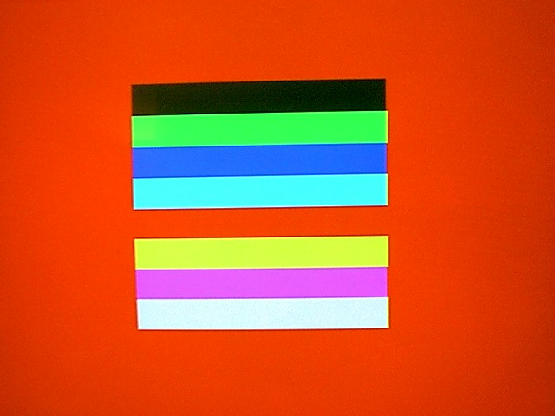

Image produced by blank RAM.

Figure 9. Blank RAM VGA View
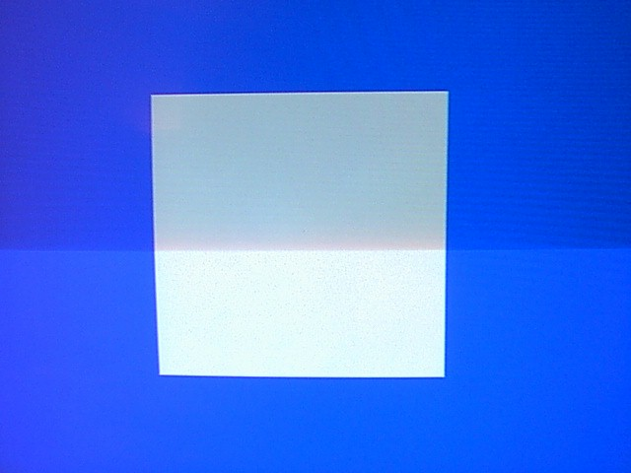

Processed image read from RAM after being written to it.

Figure 10. RAM Data VGA View

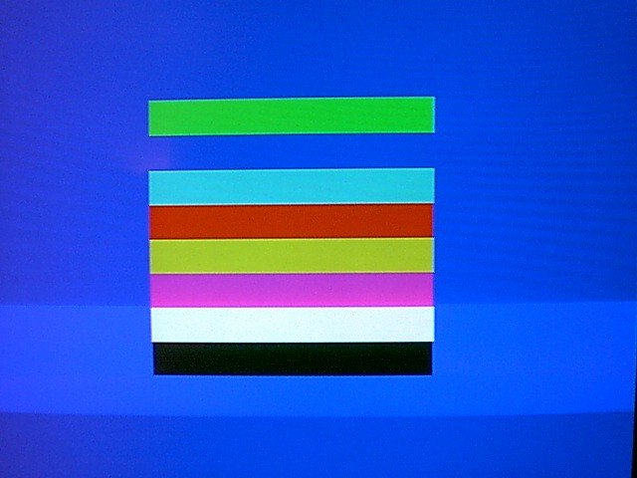

Conclusions
The project displays effective use of VHDL, Verilog, hardware chips previously unfamiliar to the designers, demo board, and commercial hardware data sheets, the interpretation, use, and integration within a proprietary design of previously existing code, and effective use of engineering practices to both create new and adapt existing techniques and designs to achieve the project objective. More than just learning and experience gained, this project is an actual working design of a potentially useful product. It is a stand alone image processor, as well as a viewer, and is capable of a much more complex application. The same basic process could just as easily read an image from a disk, perform simple photo manipulations, and write back to another disk.

The project also shows a successful implementation of modular code. The design was created using Verilog code modules that can be changed individually, allowing for code corrections without having to change the main code file. Modularity of code is a highly desired characteristic, allowing for ease of modification and maintenance.

While the original, much more involved, design appeared feasible at first, after initial investigation it quickly became clear that a simple hardware design was going to be sufficiently challenging for the scope of this project. The problems encountered during the design process came to define the final product described in the above report. The fact that pure hardware design remains at best theoretical was shown by the necessity to write software code to control the hardware.

The FPGA proved to be the appropriate technology for the application. The speed and ease of use was proof that such a device is perfect for industry rapid prototyping. The FPGA is an ideal tool to use in the design process of an processor. Only after all aspects of design have been perfected, would a chip then be sent to a fabrication laboratory and mass produced.

The finished product is, in fact, an outboard graphics processor, its simplicity notwithstanding. It would be quite easy to change the graphics_modifier module in the Verilog code to perform any desired image processing operation, such as color filtering, contrast and brightness adjustments, and smoothing operations. As it is, the processor nevertheless proves the validity of the concept and shows a successful application of it.

While the designers were able to accomplish much of the project, the project would not have succeeded without the help of several faculty members, graduate students, and staff. Please refer to the acknowledgements page for a complete list.
References
- “Fundamentals of Digital Logic with VHDL Design”, Brown and Vranesic, McGraw-Hill, Copyright ©2000.
- “Rapid Prototyping of Digital Systems”, Hamblem and Furman, Klumer Academic Publishers, Copyright ©September, 1999.
- “University Program Design Laboratory Package”, Altera Coporation, San Jose, CA 95134. Use of Altera, Max+PLUS II, FLEX, MAX, and ByteBlasterMV, Copyright ©1999 Altera Coporation. All rights reserved.

Appendix
(ITEMS IN THE APPENDIX CAN BE FOUND IN THE FOLLOWING ORDER)

- Block diagram of full project design and layout
- Photo of EPROM in setup
- Photo of SRAM in setup
- Photo of ByteBlasterMVTM in setup
- Photo of Full Project Setup
- Modular Designs in Graphical Editor
- EPROM_TESTER.GDF
- PROCESSOR.GDF
- Floorplan Editor in Altera Max+PLUS II
- Modular Code
- VGA_SYNC.vhd
- RGB_OUT.v
- RGB_OUT_BLUEBDR.v
- SIXTEENBITMUX.v
- WRITERAMMOD.v
- COLORMUX.v
- GRAPHICSMODIFIER.v
- Data Sheet for Am27C512 EPROM
- Data Sheet for UT621024 SRAM

