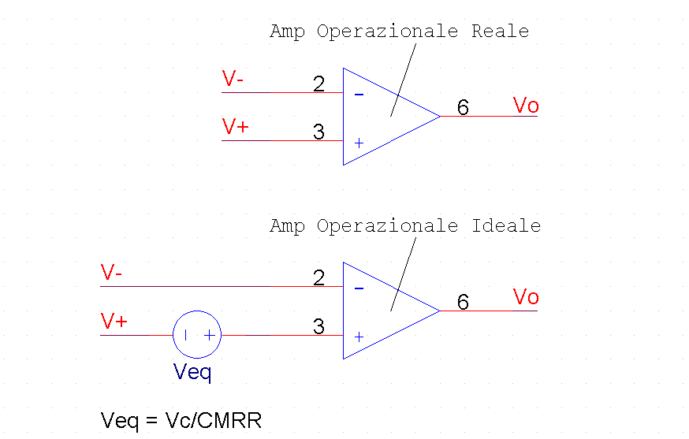

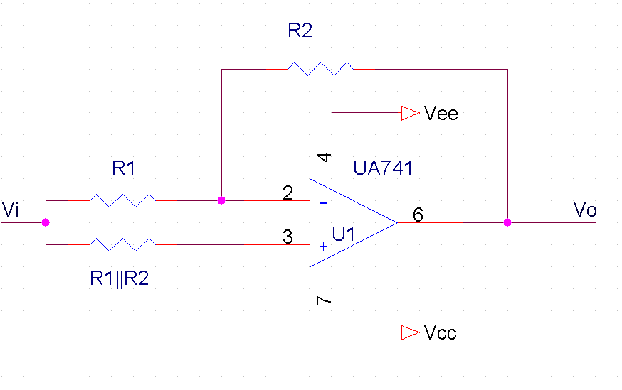
$$\text{Vo}=\text{Vi}+\frac{\text{Vi}}{\text{CMRR}}⋅\left(1+\frac{R_{2}}{R_{1}}\right)$$

$$\text{CMRR}=\frac{\text{Vi}}{(\text{Vo-Vi})}⋅\left(1+\frac{R_{2}}{R_{1}}\right)$$

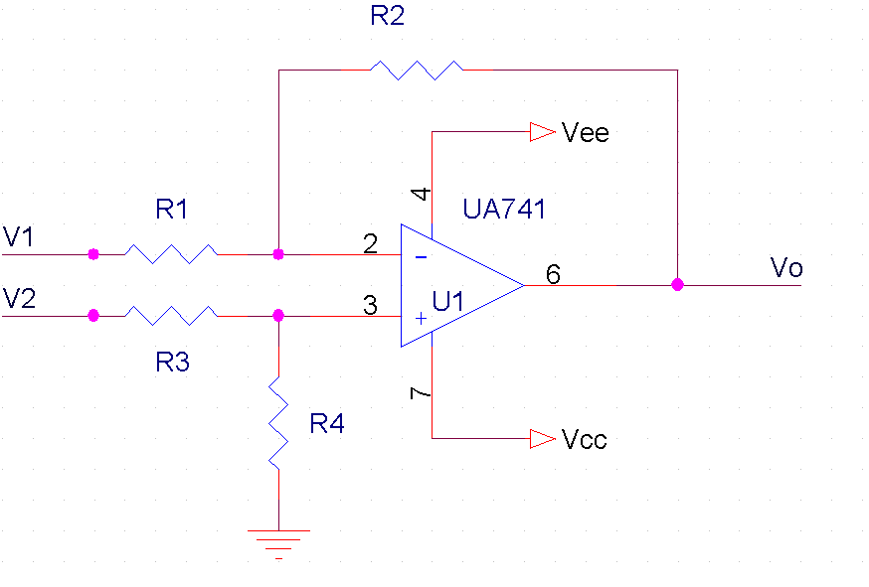

$$\text{Vo}=V_{2}⋅\frac{R_{4}}{\left(R_{4}+R_{3}\right)}⋅\frac{\left(R_{1}+R_{2}\right)}{R_{1}}−V_{1}⋅\frac{R_{2}}{R_{1}}$$

$$\text{Vo }=\text{ Ad }(V_{2}{\text{-V}}_{1})+\text{ Ac}⋅\frac{(V_{2}+V_{1})}{2} =\text{ Ac}⋅\frac{(V_{2}+V_{1})}{2}=\text{ AcVi}$$

$$\text{CMRR}=\frac{\text{Ad}}{\text{Ac}}=\frac{\text{Vi}}{\text{Vo}}$$

